SQL Server Transaction

Multiple SQL queries in a group in SQL Server may need to execute and out of the SQL Queries in the group, some of the queries may fail.

This could create data update issues and data consistency issues as a partial update could make a series of transactions incomplete.
So, there is an SQL Statement called TRANSACTION with COMMIT and ROLLBACK, which can be used to handle incomplete or partial execution of queries in a Transaction. In this article, we will discuss the different Transaction commands with examples.
This article explores SQL Server Transactions, including syntax, error handling, and best practices. The model illustrates the key role played in data integrity, which is applied to financial transactions and inventory management. Whether you’re a developer or an administrator, understanding these principles is essential to building flexible database applications.
TRANSACTION in SQL Server
A TRANSACTION in SQL Server is a single unit of work that contains one or more SQL Statements to be executed at once. The TRANSACTION statement ensures that all statements within a single transaction either succeed or fail together to maintain data consistency. If there are multiple SQL queries for Insert, Update, or Delete without a TRANSACTION statement, if one of the queries fails then the other queries get executed since each SQL statement is an independent Transaction. This could lead to errors for a targeted transaction with incomplete data updates.
TRANSACTION is based on ACID, which stands for Atomicity, Consistency, Isolation and Durability. These four characteristics define the reliability and consistency of a database transaction with one or more SQL queries as a single unit.
TRANSACTION provides a way to ensure consistency and integrity of the database when multiple SQL statements are grouped and executed in an atomic operation.
Basic Syntax:
BEGIN TRANSACTION;
-- SQL statements here
-- If everything is successful, commit the transaction
COMMIT;
-- If there is an issue, rollback the transaction
ROLLBACK;
A transaction begins with BEGIN TRANSACTION and ends with either COMMIT or ROLLBACK. When all statements inside the TRANSACTION block execute successfully, then the COMMIT statements execute to make the changes permanent in the database. But if there was a failure in one or more queries in the block, then all SQL Statements are rolled back using the ROLLBACK statement.
Example of SQL Server Transaction
Example: Using Begin Transaction and Commit Transaction
BEGIN TRANSACTION
Insert into Customers (CustName,City,State,Country) Values ('Jaya Kumar','Bangalore','KA','India')
Update Orders Set Product='iPhone 15' where Id=3
COMMIT TRANSACTION
In the above example, both SQL statements will be executes successfully.
Output in customers table:
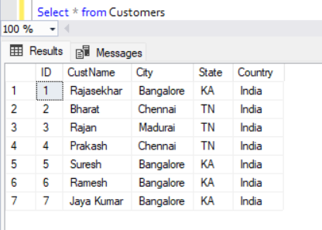Customers table data
Order Table Output after update:
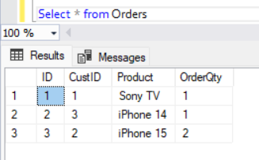Order table data
IF...ELSE Statements inside the TRANSACTION block
The COMMIT and ROLLBACK can be used inside conditional statements like IF...ELSE to commit or rollback the changes from all the SQL queries based on a specific condition.
Example: Using Begin, Commit, and Rollback Transaction with IF...ELSE Statements
BEGIN TRANSACTION
Example for using Begin, Commit, and Rollback Transaction with IF...ELSE Statements:
BEGIN TRANSACTION
Insert into Customers (CustName,City,State,Country) Values ('Vijay Kumaran','Bangalore','KA','India')
Update Orders Set Product='iPhone 14' where Id=31
If @@ROWCOUNT = 0
ROLLBACK TRANSACTION
else
COMMIT TRANSACTION
In the above example since there is no Id no 31 in orders table and the transaction will be rolled back. So no data inserted or updated as seen below:
Output:
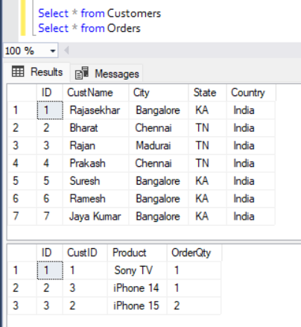IF..ELSE example no updates done
SAVE TRANSACTION
The save transaction statement can be used with a name identifier to rollback a transaction from a particular point based on some specific logic.
Example: Conditional Transaction Rollback using SAVE TRANSACTION in SQL Server
BEGIN TRANSACTION
Insert into Customers (CustName,City,State,Country) Values ('Vijay Kumaran','Bangalore','KA','India')
SAVE TRAN tran_save
Insert into Customers (CustName,City,State,Country) Values ('Kumaresan Prabhu','Chennai','TN','India')
Update Orders Set Product='iPhone 14' where Id=34
If @@ROWCOUNT = 0
ROLLBACK TRANSACTION tran_save
COMMIT TRANSACTION
In the above example the SAVETRANSaction command is used to rollback any insert or update after the SAVETRAN block if the update to Orders table is not successful as given in the example above. So when we check the table, the first Insert is successful, but second insert is rolleback and so no data inserted from this Insert statement.
Output:
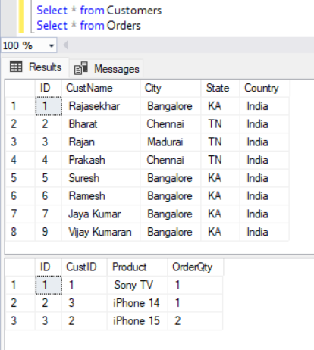SAVETRANS example output
Named Transaction in SQL Server
Each BEGIN TRANSACTION can be given a name and it can be referenced in COMMIT and ROLLBACK Statements. This will be useful when there are multiple TRANSACTION statements or nested transaction statements in a single Transaction code block.
Example: Nested Transactions with Named Transactions in SQL Server
BEGIN TRANSACTION Trans_One
Insert into Customers (CustName,City,State,Country) Values ('Raja Kumaran','Chennai','TN','India')
Begin TRANSACTION Trans_Two
Insert into Orders Values (@@IDENTITY,'SANYO TV',1)
COMMIT TRANSACTION Trans_Two
COMMIT TRANSACTION Trans_One
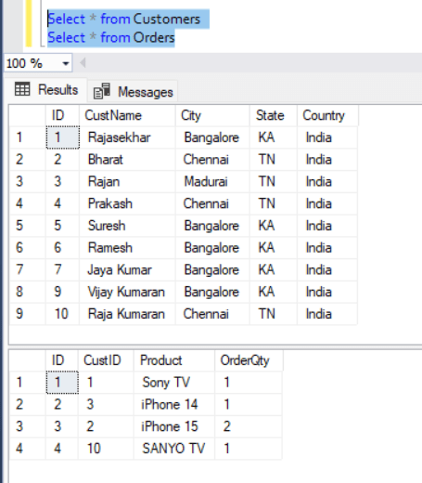Named Transaction example
Nested Transactions
TRANSACTION statements can be nested to separate multiple units of code and to only COMMIT or ROLLBACK specific TRANSACTION
Example: Nested Transactions with Selective Commit/Rollback in SQL Server
BEGIN TRANSACTION Trans_One
Insert into Customers (CustName,City,State,Country) Values ('Ramraj','Chennai','TN','India')
Insert into Orders Values (@@IDENTITY,'Soundbar BOAT 900',1)
BEGIN TRANSACTION Trans_Two
Update Orders Set Product='iPhone 14 pro max' where Id=3
COMMIT TRANSACTION Trans_Two
COMMIT TRANSACTION Trans_One
Below is the output after the above Insert and update statements
Output:
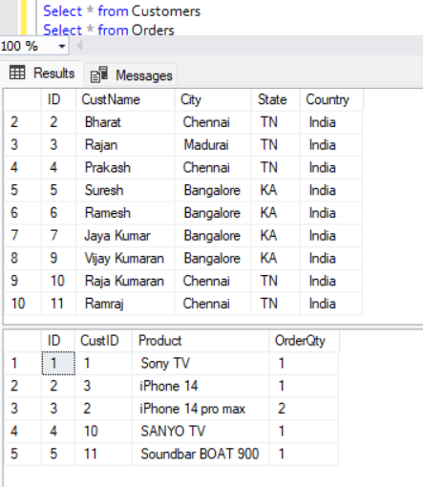Nested Transactions
Error Handling - TRY...CATCH
Error Handling block can be used to catch errors and commit or rollback the transaction accordingly as below:
Example: Error Handling with Transaction in SQL Server
BEGIN TRY
BEGIN TRANSACTION Trans_One
Insert into Customers (CustName,City,State,Country) Values ('Loganathan','Chennai','TN','India')
Insert into Orders Values (@@IDENTITY,'SANYO TV',1)
COMMIT TRANSACTION Trans_One
END TRY
BEGIN CATCH
ROLLBACK TRANSACTION Trans_One
END CATCH
Below is the data updated after the above Insert statements
Output:
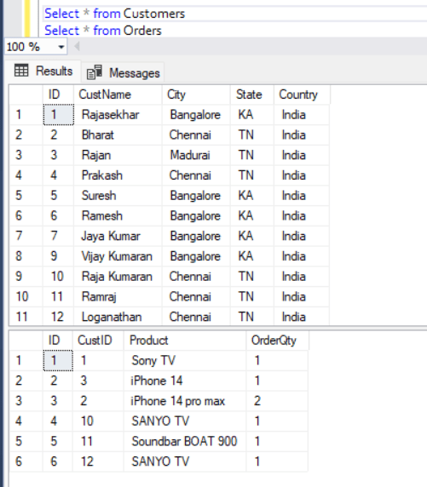Try...Catch example
Common Use Cases for TRANSACTION
1. Transferring funds between Bank Accounts
2. Inventory management of updating Orders online involving multiple tables
3. Batch Processing to make Batch Updates or Insert of data
4. Critical System Operations like updating configurations, settings or transactions to maintain consistency of the system state
5. Data Cleaning and Maintenance tasks, and prevent partial update by roll back all changes.

Implementing transactions in Microsoft SQL Server is essential for maintaining data integrity. Transactions ensure that a group of operations either all succeed (COMMIT) or all fail (ROLLBACK) — following ACID properties.

🔹 1. Basic Transaction Syntax
BEGIN TRANSACTION;
-- SQL statements
UPDATE Accounts SET Balance = Balance - 100 WHERE AccountId = 1;
UPDATE Accounts SET Balance = Balance + 100 WHERE AccountId = 2;
COMMIT;
👉 If something goes wrong, use:
ROLLBACK;

🔹 2. Simple Example (Manual Rollback)
BEGIN TRANSACTION;
UPDATE Employees
SET Salary = Salary + 5000
WHERE EmployeeID = 101;
-- Check result before committing
SELECT * FROM Employees WHERE EmployeeID = 101;
ROLLBACK; -- Undo changes

🔹 3. Transaction with Error Handling (TRY...CATCH)
This is the recommended real-world approach.
BEGIN TRY
BEGIN TRANSACTION;
UPDATE Accounts
SET Balance = Balance - 1000
WHERE AccountId = 1;
UPDATE Accounts
SET Balance = Balance + 1000
WHERE AccountId = 2;
COMMIT TRANSACTION;
END TRY
BEGIN CATCH
ROLLBACK TRANSACTION;
PRINT 'Transaction Failed';
PRINT ERROR_MESSAGE();
END CATCH;

🔹 4. Example: Bank Transfer (Real-World Scenario)
BEGIN TRY
BEGIN TRANSACTION;
DECLARE @Amount DECIMAL(10,2) = 500;
-- Debit
UPDATE BankAccounts
SET Balance = Balance - @Amount
WHERE AccountId = 1;
-- Check insufficient balance
IF (SELECT Balance FROM BankAccounts WHERE AccountId = 1) < 0
BEGIN
THROW 50000, 'Insufficient Balance', 1;
END
-- Credit
UPDATE BankAccounts
SET Balance = Balance + @Amount
WHERE AccountId = 2;
COMMIT TRANSACTION;
END TRY
BEGIN CATCH
ROLLBACK TRANSACTION;
PRINT 'Transfer Failed';
PRINT ERROR_MESSAGE();
END CATCH;

🔹 5. Nested Transactions
BEGIN TRANSACTION;
INSERT INTO Orders VALUES (1, 'Order1');
BEGIN TRANSACTION;
INSERT INTO OrderDetails VALUES (1, 'Product1');
COMMIT TRANSACTION; -- Inner commit
ROLLBACK TRANSACTION; -- Rolls back everything
👉 SQL Server does not truly support independent nested commits — outer rollback cancels everything.

🔹 6. Using SAVEPOINT (Partial Rollback)
BEGIN TRANSACTION;
INSERT INTO Products VALUES (1, 'Laptop');
SAVE TRANSACTION SavePoint1;
INSERT INTO Products VALUES (2, 'Mobile');
ROLLBACK TRANSACTION SavePoint1;
COMMIT TRANSACTION;
👉 Only "Laptop" will remain.

🔹 7. Transaction with @@TRANCOUNT
BEGIN TRANSACTION;
PRINT @@TRANCOUNT; -- 1
BEGIN TRANSACTION;
PRINT @@TRANCOUNT; -- 2
COMMIT;
PRINT @@TRANCOUNT; -- 1
ROLLBACK;
PRINT @@TRANCOUNT; -- 0

 Implementing Transactions in SQL Server
Transactions in SQL Server are used to ensure that a group of operations are executed as a single unit, maintaining data integrity even in the face of errors or system failures. A transaction typically follows the ACID (Atomicity, Consistency, Isolation, Durability) properties, ensuring reliable database operations.
Basic Transaction Example:
The following T-SQL snippet demonstrates a simple transaction:
BEGIN TRANSACTION;
UPDATE Accounts SET Balance = Balance - 5000 WHERE AccountNo = 101; -- Debit
UPDATE Accounts SET Balance = Balance + 5000 WHERE AccountNo = 202; -- Credit
IF @@ERROR = 0
COMMIT TRANSACTION;
ELSE
ROLLBACK TRANSACTION;
In the above example, if both updates succeed, the money is transferred and the transaction is committed. If there is any error, all changes are rolled back, ensuring no partial transfer occurs.
Real-World Scenario (Bank Transfer):
Consider a scenario where money is transferred from one account to another. Both debit and credit operations must succeed together, or neither should happen. Using BEGIN TRY and BEGIN CATCH blocks improves error handling:
BEGIN TRY
BEGIN TRANSACTION;
UPDATE Accounts SET Balance = Balance - 10000 WHERE AccountNo = 12345; -- Debit
UPDATE Accounts SET Balance = Balance + 10000 WHERE AccountNo = 67890; -- Credit
COMMIT TRANSACTION;
END TRY
BEGIN CATCH
ROLLBACK TRANSACTION;
-- Additional error handling logic here
END CATCH
With this approach, any runtime error during the transaction will lead to a rollback, and you can add custom error handling as needed.
Nested Transactions and SAVEPOINT:
SQL Server does not truly support independent nested commits. If an outer transaction is rolled back, all inner transactions are also rolled back. However, you can use SAVE TRANSACTION (savepoints) to partially roll back to a specific point within a transaction:
BEGIN TRANSACTION;
UPDATE Products SET Stock = Stock - 1 WHERE ProductID = 1;
SAVE TRANSACTION SavePoint1;
UPDATE Products SET Stock = Stock - 1 WHERE ProductID = 2;
-- Suppose an error occurs here
ROLLBACK TRANSACTION SavePoint1; -- Only changes after SavePoint1 are undone
COMMIT TRANSACTION;
In this case, changes made before SavePoint1 are retained, while subsequent changes can be rolled back if needed.
Using @@TRANCOUNT:
The system function @@TRANCOUNT returns the number of active transactions for the current session, which can help manage transaction nesting and control flow.
By implementing transactions thoughtfully, you can ensure data consistency and reliability in your SQL Server applications, especially for critical operations such as financial transfers and inventory updates.

